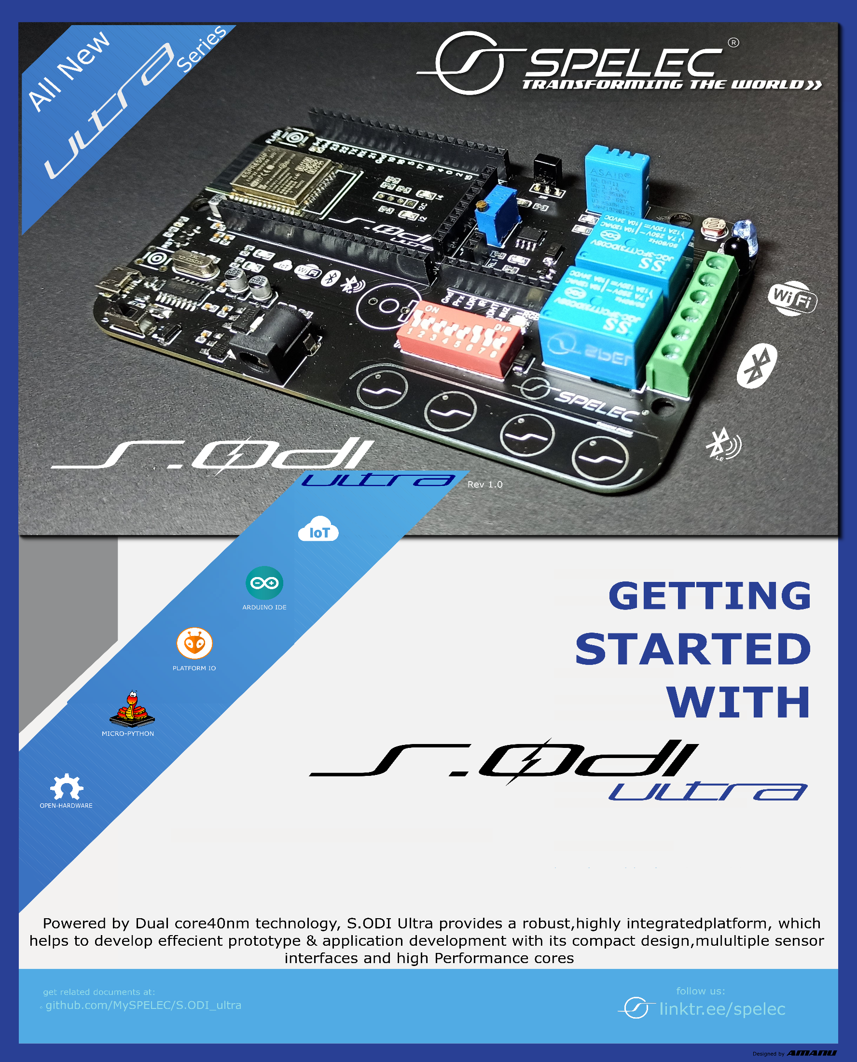hva

System. On-Board Development Interfaces

Transform your Dreams to Reality

# **Get Started**

* Introduction
* What You Need
* Guides
* S.ODI Ultra v1.0 Dev Board
  + - Overview
    - Functionality Overview
    - Functional Description
    - Board Architecture
    - Key Components
    - Setup Toolchain
    - CH340G Drivers
    - Download and Install Drivers
    - Arduino IDE
    - Installation step by step
    - Start a Project
    - Libraries & Frameworks
    - Examples
    - Micro Python
    - Esp-IDF
    - Libraries & Frameworks
    - Applications
    - Product Comparisons

System. On-Board Development Interfaces

Transform your Dreams to Reality

You can construct your intelligent hardware system with very low to no effort using our development board S.ODI developed by SPELEC.

The S.ODI (System onboard development interface) is a Development board that has integrated sensors regarding Humidity, Temperature, flame, LDR and infrared it also has RGB (LED light) which works as an indicator. S.ODI also comes with onboard WI-FI, Bluetooth, BLE which are used to connect with various devices.

With the collection of onboard hardware components and the open-source firmware that we supply one can quickly learn how to get hardware connected online, and how to use Web API and/or smartphones to interact with it.

# **Get Started**

This document is intended to help you set up the software development environment for the hardware based on the S.ODI Ultra Dev Board by SPELEC.

After that, a simple example will show you how to use S.ODI (System onboard Development Interfaces) and software’s for menu configuration, then building, and flashing firmware onto an S.ODI board.

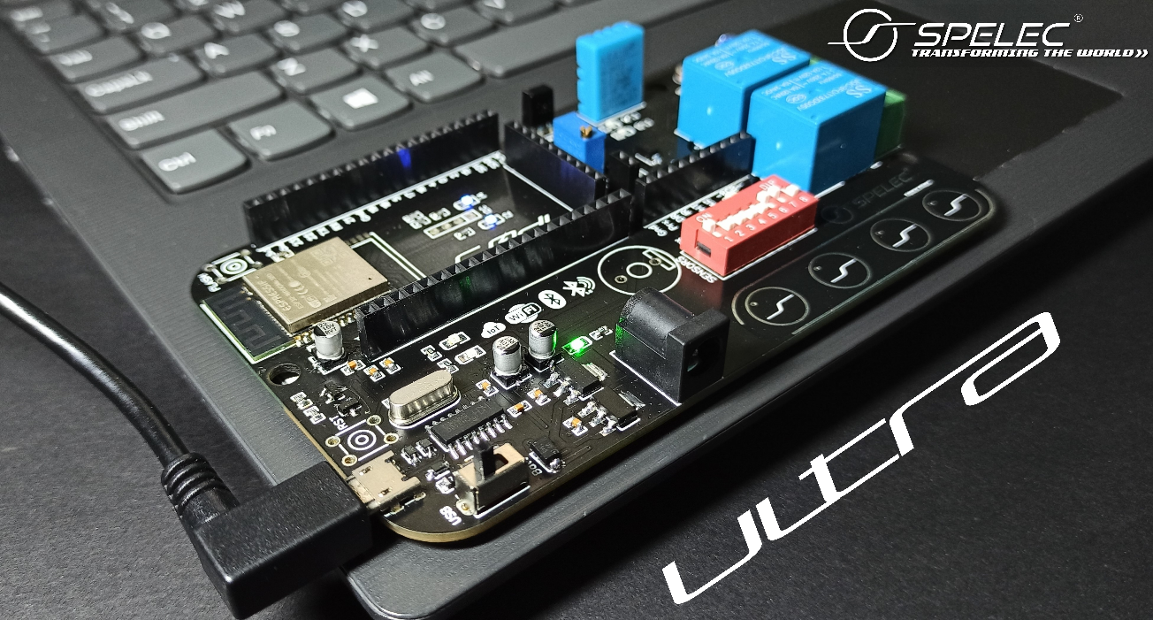

## **Introduction**

S.ODI is a system on board that integrates the following features:

* **Wi-Fi (2.4 GHz band)**
* **Bluetooth 4.2**
* **Bluetooth low Energy**
* **Infrared comm**
* **Dual high-performance cores**
* **Ultra-Low Power co-processor**
* **Several peripherals & Sensors**

# Powered by 40 nm technology, S.ODI provides a robust, highly integrated platform, which helps meet the continuous demands for efficient power usage. It also comes with compact design, security, high performance and reliability.

SPELEC provides basic hardware and software resources to help application developers realize their ideas using the S.ODI series hardware. The software development framework by SPELEC is intended

# for the development of Internet-of-Things (IoT) applications with Wi-Fi, Bluetooth, power management and several other system features.

# **What You Need**

Hardware:

* An S.ODI Dev board
* USB cable - USB A to micro B

Computer running Windows, Linux, or macOS Software:

* Arduino IDE
* ESP-IDF
* Micro-Python



S.ODI is an ESP32-based development board produced by SPELEC. This board features multiple integrated sensors and interfaces.

It’s another distinguishing feature includes the multiple Embedded Sensors, Interfaces and CH340G / CP2102 - advanced multi-interface USB bridges. This chip enables usage of UART for direct debugging of S.ODI through the USB interface. S.ODI makes development effortless, convenient, easy, and cost-effective. Most of the S.ODI I/O pins are broken out to the board's pin headers for easy access.

## **Functionality Overview**

* **Wi-Fi Key Features**

802.11 b/g/n

* 802.11 n (2.4 GHz), up to 150 Mbps
  + 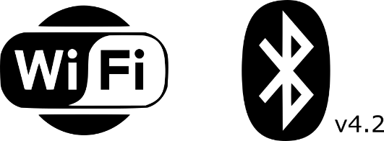 WMM
  + TX/RX A-MPDU, RX A-MSDU
  + Immediate Block ACK
  + Defragmentation
  + Automatic Beacon monitoring (hardware TSF)
  + 4 × virtual Wi-Fi interface
  + Antenna diversity

* **BT Key Features** 
  + Enhanced Power Control
  + +12 dBm transmitting power
  + NZIF receiver with –97 dBm BLE sensitivity
  + Compliant with Bluetooth v4.2 BR/EDR and BLE specification
  + Class-1, class-2 and class-3 transmitter without external power amplifier
  + 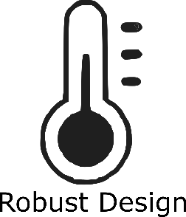Adaptive Frequency Hopping (AFH)
  + Standard HCI based on SDIO/SPI/UART
  + High-speed UART HCI, up to 4 Mbps
  + Bluetooth 4.2 BR/EDR BLE dual mode controller
  + Synchronous Connection-Oriented/Extended (SCO/eSCO)
  + CVSD and SBC for audio codec
  + Bluetooth Pico net and Scatter net
  + Multi-connections in Classic BT and BLE
  + Simultaneous advertising and scanning
  + Ultra-Low Power Consumption
* **MCU and Advanced Features**

|  |  |  |  |  |
| --- | --- | --- | --- | --- |
| PROCESSOR  SERIES | PROCESSOR  CORES | EMBEDDED  FLASH MEM. | PACKAGE  SIZE | |
| ESP32-  D0WDQ6 |  | 16MB |  |  |

* **CPU and Memory**
* 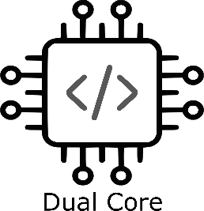Xtensa® single-/dual-core
* 32-bit LX6 microprocessor(s), up to 600 MIPS
* 16 MB FLASH Memory
* 520 KB SRAM
* 16 KB SRAM in RTC
* QSPI supports multiple flash/SRAM chips

* **Clocks and Timers**
* Internal 240 MHz oscillator with calibration
* Internal RC oscillator with calibration
* External 2 MHz ~ 60 MHz crystal oscillator (40 MHz only for Wi-Fi/BT functionality)
* External 32 kHz crystal oscillator for RTC with calibration
* Two timer groups, including 2 × 64-bit timers and 1 × main watchdog in each group
* One RTC timer
* RTC watchdog

* **Advanced Peripheral Interfaces**
* 30 × programmable GPIOs
* 12-bit SAR ADC up to 18 channels
* 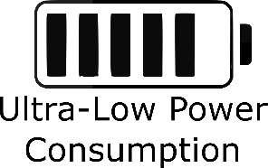2 × 8-bit DAC
* 10 × touch sensors (4 On-board)
* 4 × Hi-SPI
* 2 × I²S
* 2 × I²C
* 3 × UART
* 1 host (SD/eMMC/SDIO)
* 1 slave (SDIO/SPI)
* Ethernet MAC interface with dedicated DMA and IEEE 1588 support
* CAN BUS 2.0

* 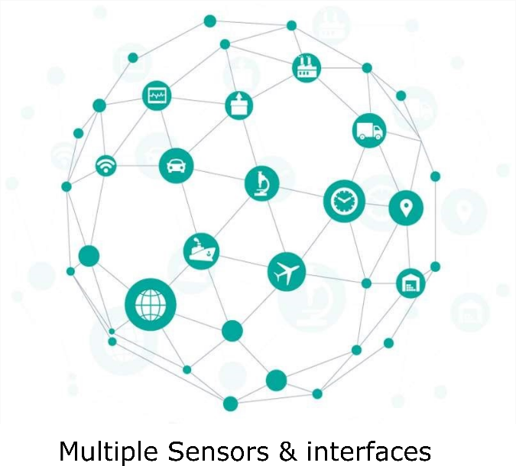**Flash encryption**
* 1024-bit OTP, up to 768-bit for customers
* Cryptographic hardware acceleration

* **On-board Sensors and Interfaces**
* Motor PWM
* LED PWM up to 16 channels
* Hall sensor
* Temperature and Humidity Sensor
* Proximity Sensor o Dual Channel Relay’s
* 4 Touch Sensor’s
* LDR
* Buzzer
* DHT Sensor
* Infrared Remote
* Thermal sensor
* RGB LED

## **Development**

* [Arduino](https://www.arduino.cc/) IDE (C++)
* [Zephyr Project](https://www.zephyrproject.org/)

A scalable real-time operating system (RTOS) supporting multiple hardware architectures, optimized for resource constrained devices, and built with security in mind.

* [Mongoose OS](https://mongoose-os.com/)
* [Amazon](https://docs.aws.amazon.com/freertos/latest/userguide/getting_started_espressif.html) AWS IoT
* [Internet button & Amazon AWS IoT](https://aws.amazon.com/blogs/apn/aws-iot-on-mongoose-os-part-1/)
* [Secure remote device management](https://mongoose-os.com/blog/secure-remote-device-management-with-mongoose-os-and-aws-iot-for-esp32-esp8266-ti-cc3200-stm32/)
* [Micro Python](https://docs.micropython.org/en/latest/esp32/tutorial/intro.html)
* [Lua Script](https://github.com/whitecatboard/Lua-RTOS-ESP32)
* [Lua Node](https://nodemcu.readthedocs.io/en/dev-esp32/)

Programming with the Lua programming language directly or using a block-based programming language that translates blocks to Lua.

* [Espruino (java script based firmware)](https://www.espruino.com/ESP32)

etc…….

## **Functional Description**

**USB-to-UART Bridge**

A single chip USB-to-UART bridge provides up to 3 Mbps transfers rates.

**Boot Button**

Download button - holding down the Boot button and pressing the EN button initiates the firmware download mode. Then user can download firmware through the serial port. EN Button

Reset button - pressing this button resets the system*.*

**Micro USB Port**

USB interface- It functions as the power supply for the board and the communication interface between PC and the ESP module. Power on LED -Turns on when the power supply is applied to the board.

**I/O Connector**

Most of the pins on the ESP module are broken out to the female pin headers on the board. Users can program ESP32 to enable multiple functions such as **PWM, ADC, DAC, I2C, I2S, SPI**, etc.

## **Board Architecture**

**Function Block Diagram of S.ODI ultra**

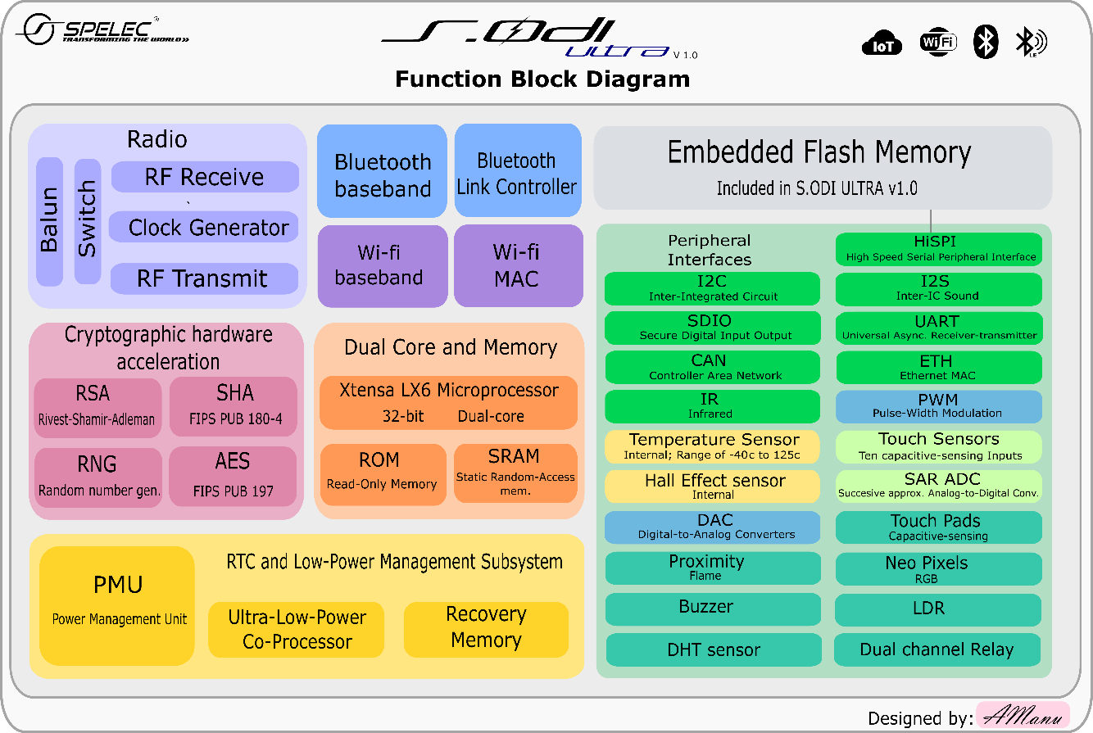

**Pin Description**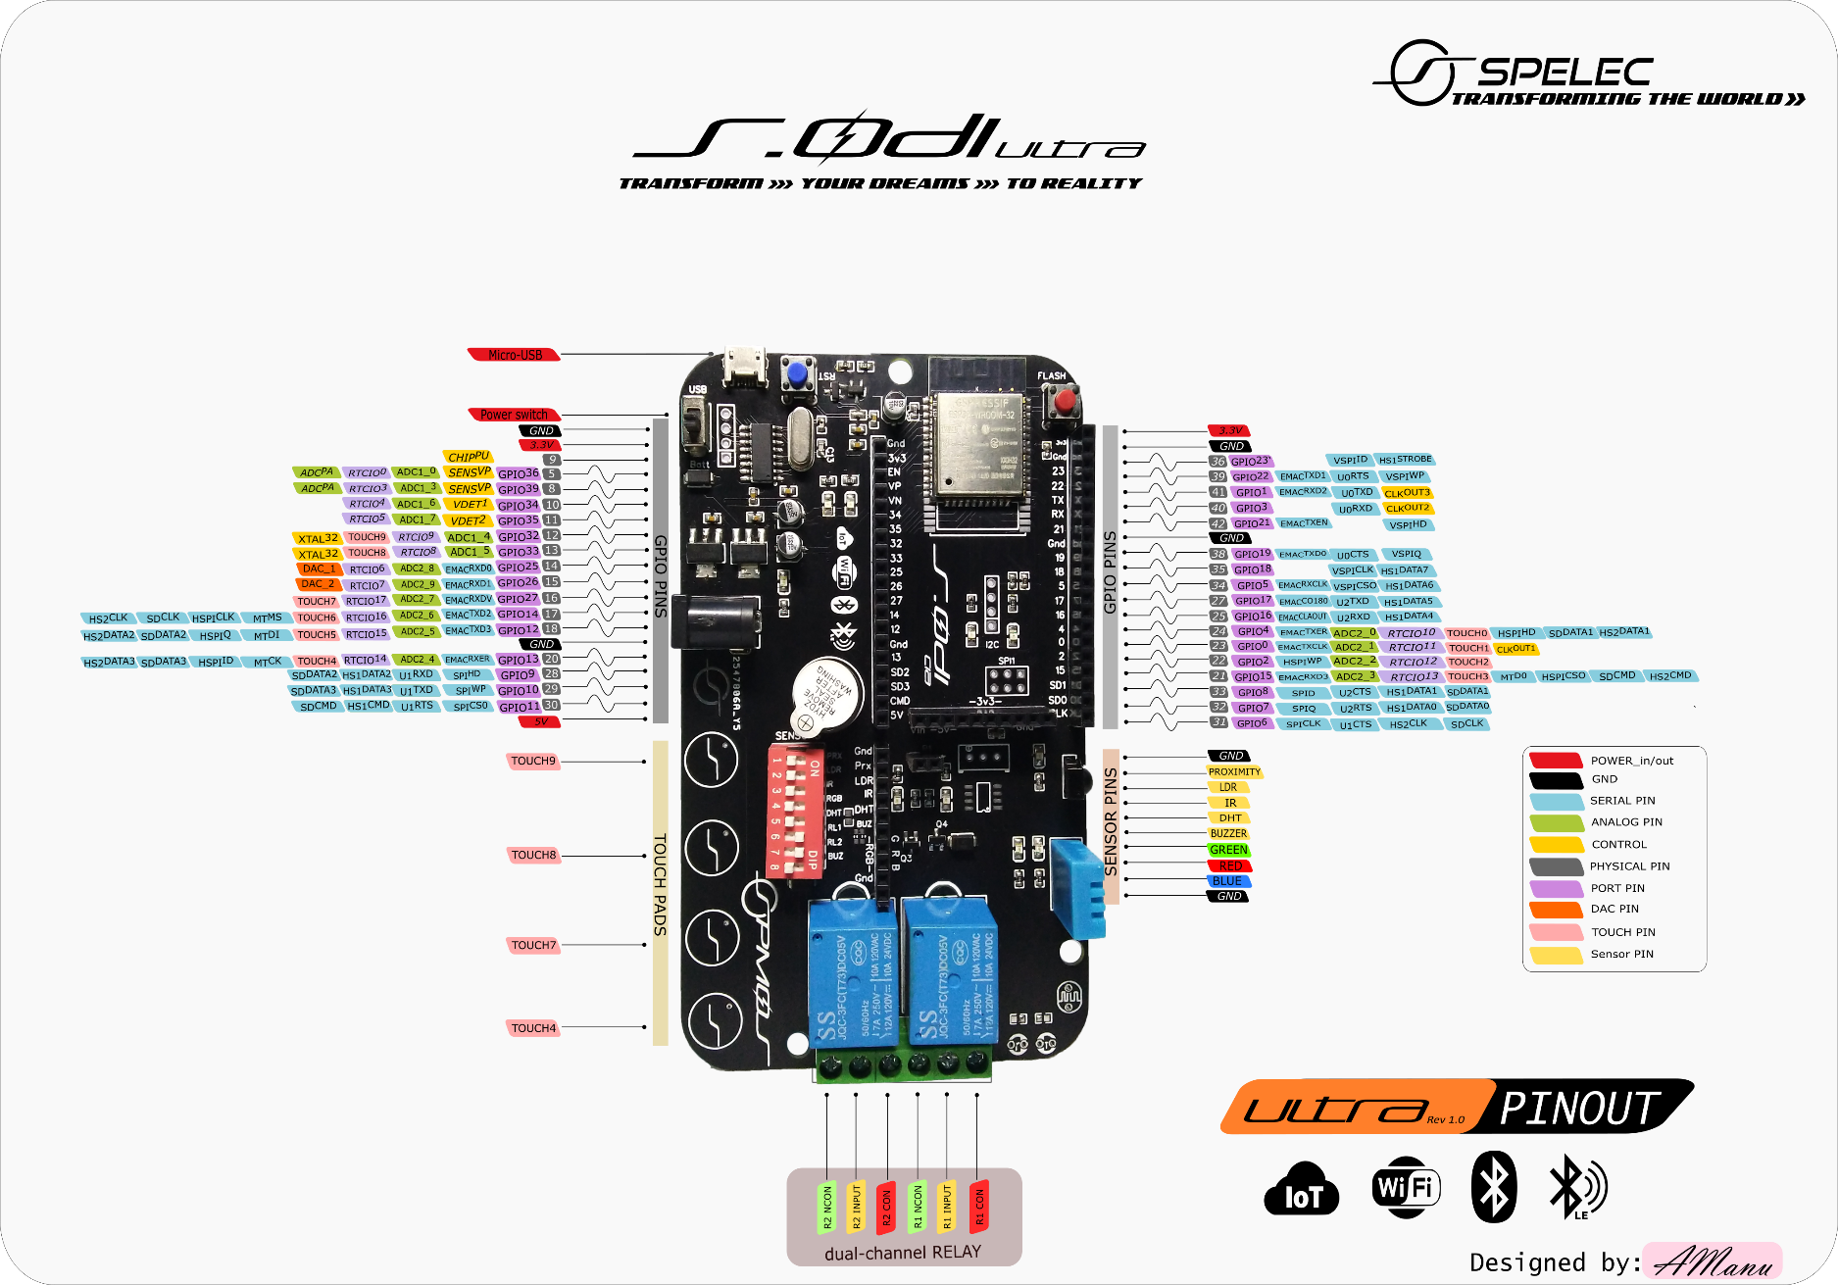

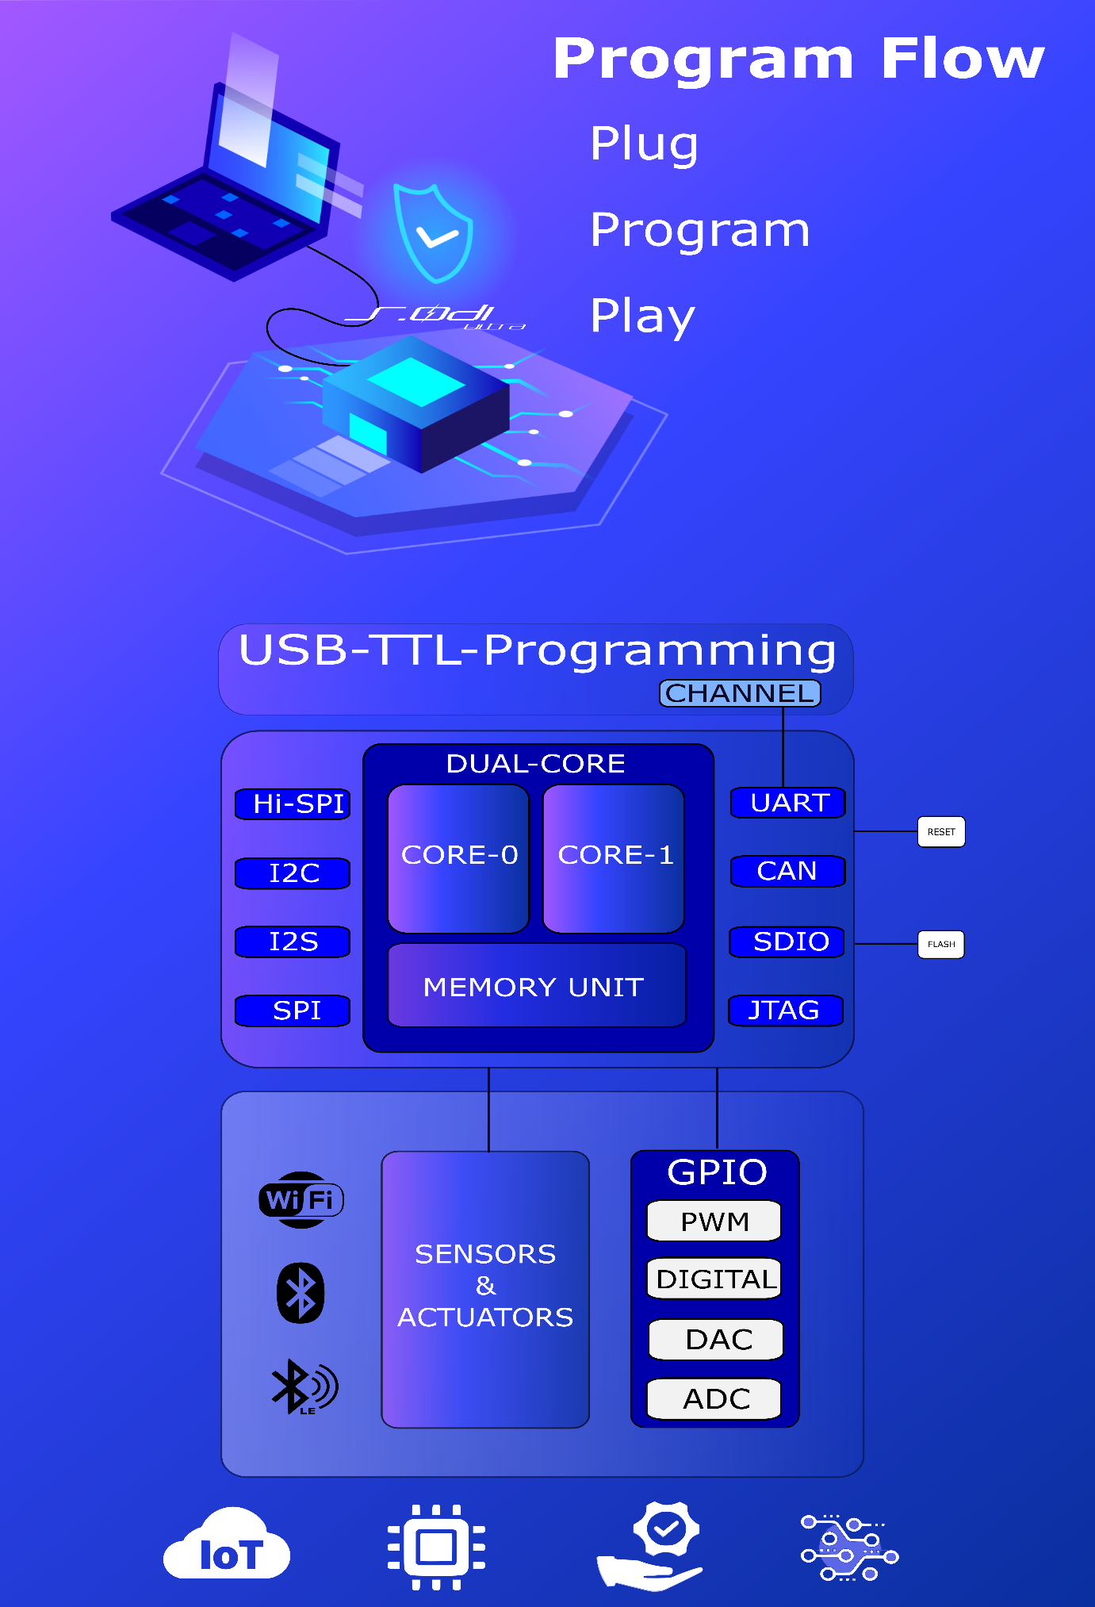

|  |  |  |  |  |
| --- | --- | --- | --- | --- |
| GPIO | Input | Output | Multiplexed | Notes |
| 0 | pulled up | OK | ADC2_1, Touch 1, RTC_11 | outputs PWM signal at boot   RTC GPIO is routed to the RTC Low-Power Subsystem. |
| 1 | TX pin | OK |  | debug output at boot |
| 2 | OK | OK | ADC2_2, Touch 2, RTC_12 | connected to the on-board LED 1 RTC Low-Power Subsystem. |
| 3 | OK | RX pin |  | HIGH at boot |
| 4 | OK | OK | ADC2_0, Touch 0, RTC_10 | connected to the on-board LED 2  RTC Low-Power Subsystem. |
| 5 | OK | OK | VSPI CSO | outputs PWM signal at boot |
| 6 | x | x | SCK/CLK | connected to the integrated SPI flash |
| 7 | x | x | SDO/SD0 | connected to the integrated SPI flash |
| 8 | x | x | SDI/SD1 | connected to the integrated SPI flash |
| 9 | x | x | SHD/SD2 | connected to the integrated SPI flash |
| 10 | x | x | SWP/SD3 | connected to the integrated SPI flash |
| 11 | x | x | CSC/CMD | connected to the integrated SPI flash |
| 12 | OK | OK | HSPI MISO, RTC_15, ADC2_5 | boot fail if pulled high. RTC Low-Power Subsystem. |
| 13 | OK | OK | Touchpad 4, HSPI, RTC_14, ADC2_4 | Touch 4,  RTC Low-Power Subsystem. |
| 14 | OK | OK | HSPI CLK, RTC_16, ADC2_6 | outputs PWM signal at boot, SPI CLK RTC Low-Power Subsystem. |
| 15 | OK | OK | ADC, Touch 3, HSPI CS, RTC_13, ADC2_3 | outputs PWM signal at boot RTC Low-Power Subsystem. |
| 16 | OK | OK | HSPI Data4 | U2 Rx |
| 17 | OK | OK |  | U2 Tx |
| 18 | OK | OK |  | VSPI CLK |
| 19 | OK | OK |  | VSPI MISO |
| 21 | OK | OK |  | SDA of I2C |
| 22 | OK | OK |  | SCL OF I2C |
| 23 | OK | OK |  | VSPI MOSI |
| 25 | OK | OK | RTC_6, ADC2_8, DAC_1 | DAC(Digital to Analog Converter) RTC Low-Power Subsystem. |
| 26 | OK | OK | RTC_8, ADC2_9, DAC_1 | DAC(Digital to Analog Converter) RTC Low-Power Subsystem. |
| 27 | OK | OK | TouchPad 7, RTC_17, ADC2_7 | TouchPad 7 RTC Low-Power Subsystem. |
| 32 | OK | OK | TouchPad 9, RTC_9, ADC1_4 | TouchPad 9 RTC Low-Power Subsystem. |
| 33 | OK | OK | TouchPad 8, RTC_8, ADC1_5 | TouchPad 8 RTC Low-Power Subsystem. |
| 34 | OK |  | RTC_4, ADC1_6 | Input only RTC Low-Power Subsystem. |
| 35 | OK |  | RTC_5, ADC1_7 | Input only RTC Low-Power Subsystem. |
| 36 | OK |  | RTC_0, ADC1_0 | Input only RTC Low-Power Subsystem. |
| 37 | OK |  | ADC1_1 | ADC input channels |
| 38 | OK |  | ADC1_2 | ADC input channels |
| 39 | OK |  | RTC_3 | Input only RTC Low-Power Subsystem. |
| Prx |  | OK | Sensor pin | output only  Proximity Sensor |
| LDR |  | OK | Sensor pin | output only  LDR (Light Dependent Resistor) used in light varying sensor circuits. |
| IR | OK | OK |  | IR(Infrared) communication |
| DHT |  | OK | Sensor pin | output only  DHT 11 sensor |
| BUZ | OK |  | Actuators pin | Buzzer for audio Signalling devices, alarms. |
| RGB | OK |  | RGB pin | Neo Pixel PWM and Digital supported. |
| And | OK |  |  | Power Grounding |
| R1 | OK |  | Actuator pin | input only  Relay1 Control Unit |
| R2 | OK |  | Actuator pin | input only  Relay2 Control Unit |
| USB |  |  | Power switch-USB power | USB Power. |
| Batt | DC Jack |  | DC-input | switch to battery mode. |

## **Key Components**

|  |  |  |  |  |
| --- | --- | --- | --- | --- |
| Key Components | Description | | | |
| USB-TTL CH340G | CH340 is a USB bus converter chip and it can realize USB converter to serial interface, USB converter to IrDA infrared or USB converter to printer interface. In serial interface mode, CH340 supplies common MODEM liaison signal, used to enlarge asynchronous serial interface of a computer or upgrade the common serial device to USB bus directly Defragmentation | | | |
| 12MHz Program OSC | To synchronize the programming serial data to be written into the processor | | | |
| PWR SWITCH | To switch ON/OFF the MCU with USB power or external power source | | | |
| DUAL CORE PROCESSOR | This is a 32bit dual core processor featuring  16 MB of Memory and 512KB RAM with  240MHz clock which runs up to 600 MIPS | | | |
| Antenna FOR Wi-Fi, Bluetooth, BLE | The 2.4 GHz transmitter modulates the quadrature baseband signals to the 2.4 GHz RF signal and drives the antenna with a high-powered Complementary Metal Oxide Semiconductor (CMOS) power amplifier. It delivers up to +20.5 dBm of power for an 802.11b transmission and +18 dBm for an 802.11n transmission. | | | |
| HISPD-SPI | ESP32 features three SPIs (SPI, HSPI and VSPI) in slave and master modes in 1-line full-duplex and 1/2/4-line half-duplex communication modes. Four modes of SPI transfer format, which depend on the polarity (CPOL) and the phase (CPHA) of the SPI clock up to 80 MHz to 64-byte FIFO. All SPIs can also be connected to the external flash/SRAM and LCD. Each SPI can be served by DMA controllers. | | | |
| 2x On-board PWM LED | These are 2 pulse width modulation enabled LED’s connected to GPIO-2 and GPIO-4 | | | |
| DC external Power | To give external power from 9V to 5V | | | |
| Buzzer | On-board buzzer for applications | | | |
| Sensor Switch | To switch ON/OFF the sensors on board | | | |
| Proximity & Flame | IT is used to detect the presence of nearby objects without any physical contact. | | | |
| IR Sensor | Used to transmit and receive infrared rays for IR remote application and wireless IR transmissions | | | |
| 4+6 Touch Sensor | These are capacitive touch sensors on board for T4, T7, T8, T9(13,27,33,32) and 6 touch sense enabled pins | | | |
| LDR Sensor | Light Dependent resistor sensor is used to detect light | | | |
| DHT-Sensor | Digital Humidity and Temperature Sensor is used to find the humidity and temperature of the surroundings | | | |
| Dual-channel Relay | Dual relay unit for switching high voltage devices for IoT applications | | | |
| Sensor threshold adjusters | To adjust the threshold of the digital sensors for various applications | | | |
| Hall & CPU temp Sensor | Integrated with a Hall sensor based on a N carrier resistor. When the chip is in the magnetic field, the Hall sensor develops a small voltage laterally on the resistor, which can be directly measured by the ADC. | | | |
| SD-card interface | External SD-card interfacing GPIO’s for Memory Expansion and Data applications. | | | |
| USB interface | Universal Serial Bus type-B for serial data programming and serial monitoring providing read and write applications for  the processor. | | | |
| GPIO’s |  | All the pins on the S.ODI are broken out to pin headers. You can program S.ODI to enable multiple functions, such as PWM, ADC, | |  |
|  | |
| DAC, I2C, I2S, SPI, etc |  |

# **Setup Toolchain**



Windows

Linux

Mac OS

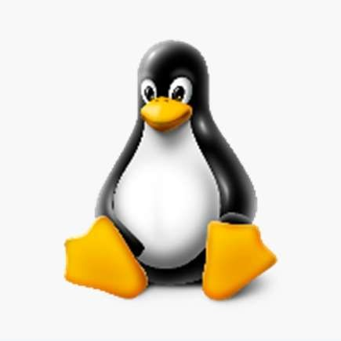

# eedu g

**For Programmer CH340G Drivers**

Download and Install S.ODI Programmer Drivers

The CH340 chip is used by several Arduino compatible boards to provide USB connectivity, you may need to install a driver, don’t panic, it’s much easier than it sounds all you need to do is just click on the link provided below and install it and follow the instructions provided below.

Get the drivers here: [S.ODI ultra-programmer drivers](https://sparks.gogo.co.nz/ch340.html)

**Arduino IDE**

Using Arduino IDE with the development repository

* [Instructions for Windows](https://www.arduino.cc/en/guide/windows)
* [Instructions for Mac](https://www.arduino.cc/en/guide/macOSX)
* [Instructions for Debian/Ubuntu Linux](https://www.arduino.cc/en/guide/linux)

### **Prerequisites: Arduino IDE Installed**

Before starting this installation procedure, make sure you have the latest version of Arduino IDE installed in your computer. If you don’t, uninstall it and install it again. Otherwise, it may not work.

Having the latest Arduino IDE software installed from [arduino.cc/en/Main/Software](https://www.arduino.cc/en/Main/Software), continue with this tutorial.

### **Installing step by step S.ODI ESP32 Add-on in Arduino IDE**

To install the S.ODI Dev board in your Arduino IDE, follow these next instructions:

1. In your Arduino IDE, go to File> Preferences

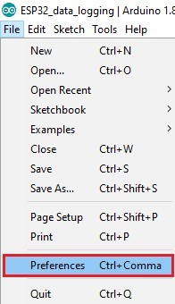

1. Enter https://dl.espressif.com/dl/package_esp32_index.json into the “Additional Board Manager URLs” field as shown in the figure below. Then, click the “OK” button:

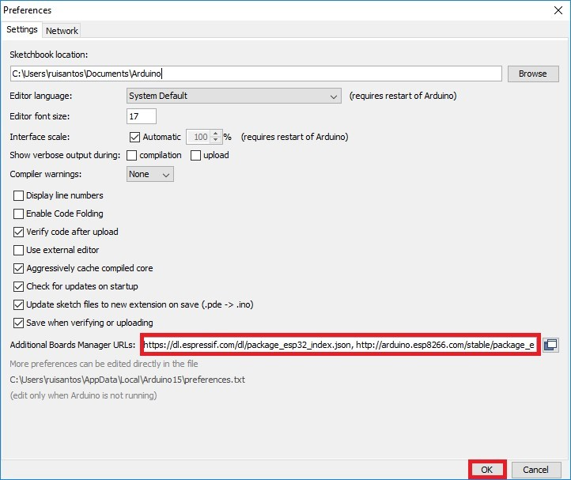

Note: if you already have the ESP8266 boards URL, you can separate the URLs with a comma as follows:

https://raw.githubusercontent.com/espressif/arduino-esp32/gh-pages/package_esp32_index.json

1. Open the Boards Manager. Go to Tools > Board > Boards Manager…

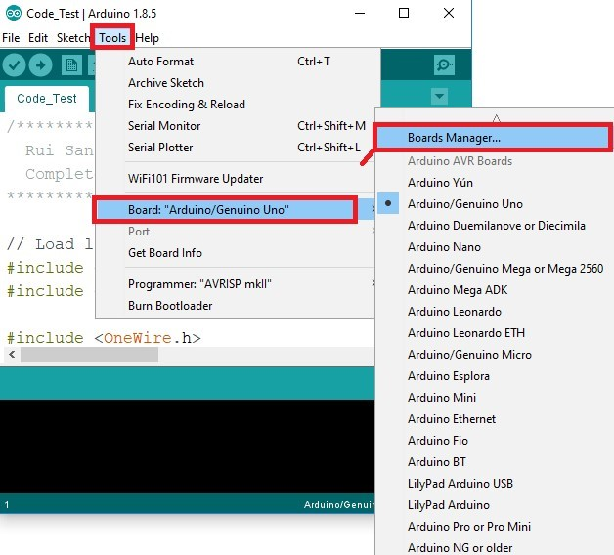

1. 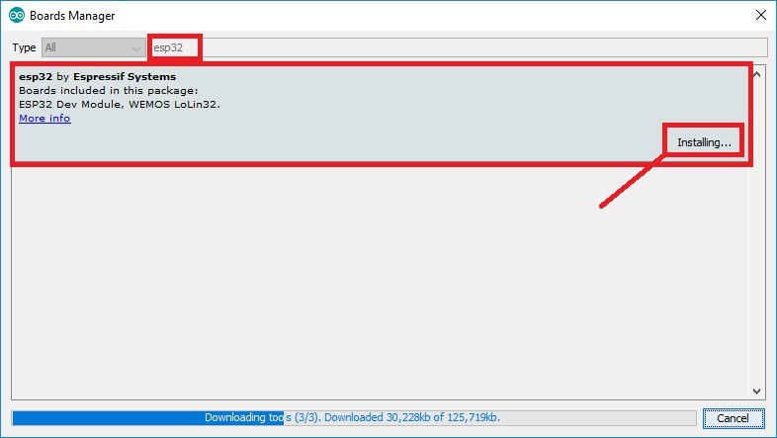Search for ESP32 and press install button for the “ESP32 by Espressif Systems“:
2. That’s it. It should be installed after a few seconds.

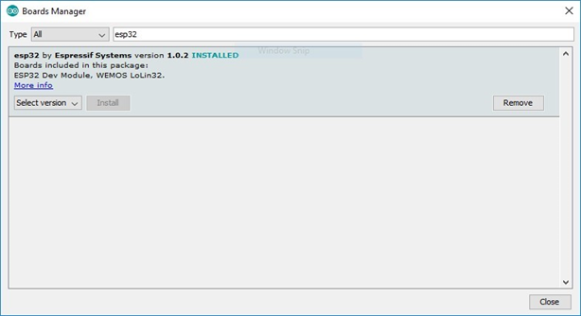

### **Start a Project**

Plug the S.ODI Dev board to your computer. With your Arduino IDE open, follow these steps:

1. Select your Board in Tools > Board menu (in my case it’s the)

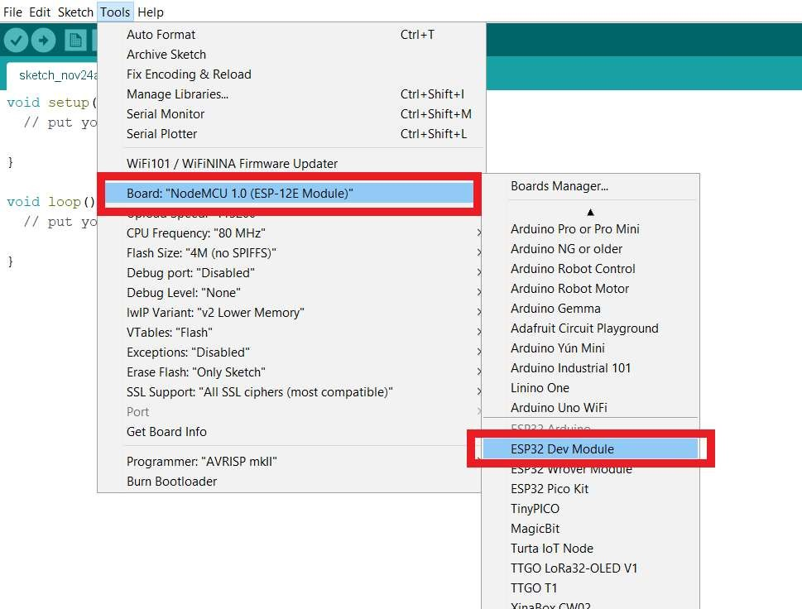

1. Select the Port (if you don’t see the COM Port in your Arduino IDE, you need to install the

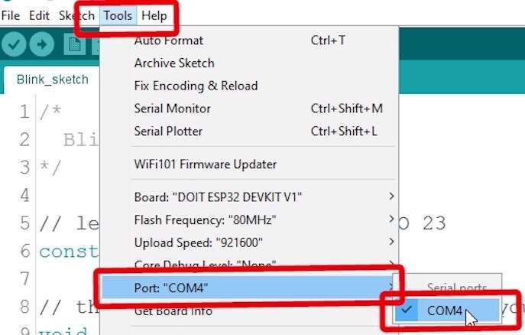 CH340G USB to UART - TTL DRIVER):

1. 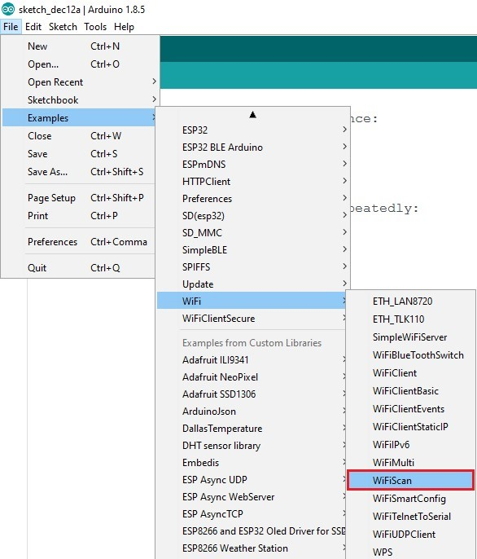Open the following example under File > Examples > WIFI (ESP32) > WIFI Scan

1. A new sketch opens in your Arduino IDE:

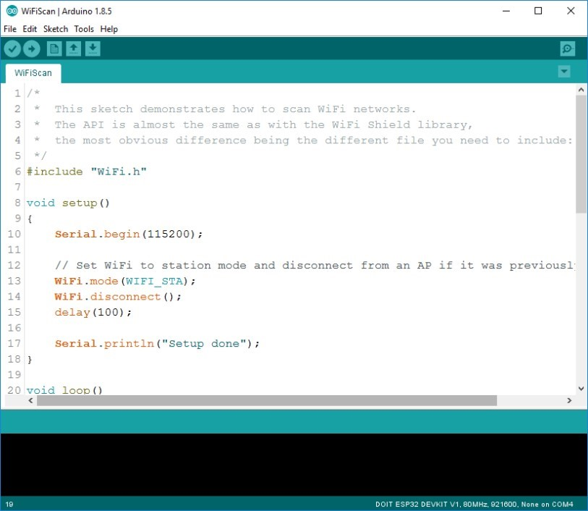

1. Press the Upload button in the Arduino IDE. Wait a few seconds while the code compiles and uploads to your board.



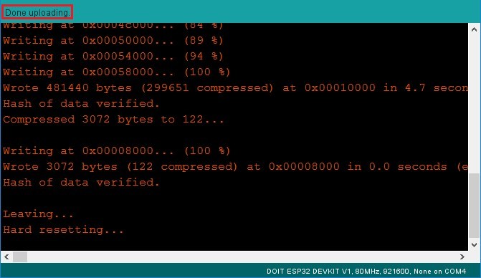6. If everything went as expected, you should see a “Done uploading.” message.

1. Open the Arduino IDE Serial Monitor at a baud rate of 115200:



1. Press the S.ODI on-board Enable button and you should see the networks available near your S.ODI :

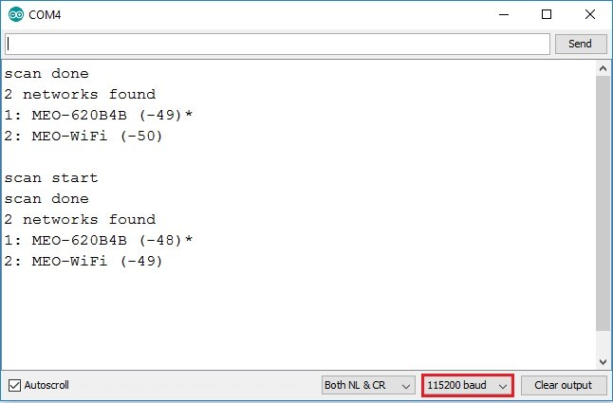

### **Libraries & Frameworks**

Arduino-esp32 includes libraries for Arduino compatibility along with some object wrappers around hardware specific devices. Examples are included in the examples folder under each library folder. The ESP32 includes additional examples which need no special drivers.

https://github.com/espressif/arduino-esp32/tree/master/libraries

**Arduino OTA:** Over the Air firmware update daemon.

Use espota.py to upload to the device.

**Async UDP:** Asynchronous task driven UDP datagram client/server

**Azure IoT:** Library to interact with Microsoft Azure IoT services

**BLE:** Bluetooth Low Energy v4.2 client/server framework

**Bluetooth Serial**: Serial to Bluetooth redirection server

**DNS Server**: A basic UDP DNS daemon (includes captive portal demo)

**EEPROM:** Arduino compatibility for EEPROM (using flash)

**ESPmDNS:** mDNS service advertising

**FFat:** FAT indexed filesystem on SPI flash

**FS:** Filesystem virtualization framework

**HTTP Client:** A simple HTTP client, compatible with WiFiClientSecure

**HTTP Update:** Download a firmware update from HTTP and apply it using Update

**NetBIOS:** NetBIOS name advertiser

**SD input:** Secure Digital card filesystem using SPI access

**SD_MMC:** Secure Digital card filesystem using 4-lane access

**Simple BLE:** Minimal BLE advertiser

|  |  |  |
| --- | --- | --- |
| **SPI:** Arduino compatible Serial Peripheral  Interface driver (master only)  **SPIFFS:** SPI Flash Filesystem  (see spiffs-plugin to upload to device)  **Ticker:** A timer to call functions on an interval  Update Sketch Update using ESP32 OTA  Functionality.  **ESP32 Additional examples** | **Webserver:** A simple HTTP daemon  Wi-Fi Arduino compatible Wi-Fi driver (includes Ethernet driver)  **Wi-Fi Client Secure:** Arduino compatible Wi-Fi client object using embedded encryption  **Wire:** Arduino compatible I2C driver (master | |
|  |  |
| * Analog Out * Camera * Chip ID * Deep Sleep * ESP Now * Free RTOS * GPIO |  | * Hall Sensor * I2S * Reset Reason * RMT * Time * Timer * Touch |

### **ESP-IDF installation guide**

Related Documents

Go to this link to get support: [ESP-IDF installation](https://docs.espressif.com/projects/esp-idf/en/latest/esp32/get-started/index.html#step-2-get-esp-idf)

**Micro Python Installation Guide**

Related Documents

Go to this link to get support: [Micro Python Installation](https://docs.micropython.org/en/latest/esp32/tutorial/intro.html)

# **Applications**

* **Generic Low-power IoT Sensor Hub**
* **Generic Low-power IoT Data Loggers**
* **Cameras for Video Streaming**
* **Over-the-top (OTT) Devices**
* **Speech Recognition**
* **Image Recognition**
* **Mesh Network**
* **Home Automation** 
  + Light control
  + Smart plugs
  + Smart door locks
* **Smart Building** 
  + Smart lighting Energy monitoring
  + Smart cities
  + Smart Grids
* **Industrial Automation** 
  + Industrial wireless control
  + Industrial robotics
* **Smart Agriculture**
* **Wi-Fi-enabled Toys**
* Smart greenhouses
* Remote control toys
* Smart irrigation
* Proximity sensing toys
* Agriculture robotics
* Educational toys
* **Audio Applications**

• **Wearable Electronics**

* Internet music players
* Smart watches
* Live streaming devices
* Smart bracelets
* Internet radio players
* Audio headsets

* **Service robots**
* **Health Care Applications**
* Cleaning Robots
* Health monitoring
* Autonomous cars
* Baby monitors
* Automated Toll Gates

## **Product Comparisons**

**Based on trending boards available**

|  |  |  |  |  |
| --- | --- | --- | --- | --- |
| **Specs & Features** | **Arduino** | **Node-MCU** | **STM32(F103)** | **S.ODI ultra** |
| **processor cores** | Single | Single | Single | **Dual** |
| **Architecture** | ‎ ‎AVR‎ RISC  (8-Bit) | ‎ESP8266(LX106)  (32-Bit) | Arm Cortex-M3 (32-Bit) | **Xtensa LX6  (32-Bit)** |
| **CPU frequency** | 16MHz | 80MHz | 72MHz | **240MHz** |
| **Speed**  **(1000000 operations)** | 7.11sec | 3.82sec |  | **0.39sec** |
| **Wi-Fi** | No | Yes | No | **Yes** |
| **Bluetooth** | No | No | No | **Yes (v4.2)** |
| **BLE** | No | No | No | **Yes** |
| **Flash** | 32KB | 4MB | 64KB | **16MB** |
| **EEPROM** | 1KB | 4 to 4096 Bytes | NA | **4KB** |
| **SRAM** | 2KB | 128KB | 20KB | **520KB** |
| **GPIO** | 14 (10-Bit) | 17 (10-Bit) | 32 (12-Bit) | **38** (12-Bit) |
| **Busses** | SPI, I2C, UART | SPI, I2C, UART, I2S | SPI, 2-I2C,  3-UART, CAN, USB | **High-Speed SPI,**  **2-I2C, 2-I2S,**  **3-UART, SDIO, CAN** |
| **Proximity Sensor** | No | No | No | **Yes** |
| **LDR Sensor** | No | No | No | **Yes** |
| **IR Comm** | No | No | No | **Yes** |
| **DHT Sensor** | No | No | No | **Yes** |
| **Buzzer** | No | No | No | **Yes** |
| **Neo Pixel (RGB)** | No | No | No | **Yes** |
| **Relays (R1 & R2)** | No | No | No | **Yes** |
| **PWM** | 6 | 10 | 20 | **32** |
| **Input voltage** | 5v-9v | 3.3v - 5v | 2v – 3.6v | **5v - 25v** |